**Coordinate Based Localization Precision Estimator**

A short introduction:

**About *Coordinate Based Localization Precision Estimator***

*Coordinate Based Localization Precision Estimator* (CBLPE) is a command line based tool, written in python, for analyzing localization precision of SMLM data.

**Requirements**

CBLPE is platform independent. It requires [Python 2.7](http://www.python.org/), [Numpy](http://www.numpy.org/), [Scipy](http://www.scipy.org/), and Tkinter to be installed. CBLPE uses the Malk output format of [rapidSTORM](http://www.super-resolution.biozentrum.uni-wuerzburg.de/research_topics/rapidstorm/) by Steve Wolter, which can be downloaded for free. However, in principle it is working with localization files from every molecule localization microscopy (SMLM) software by editing the source code definition (def loadfile(Locs, Name)), or assimilating the localization output format to the Malk format (see section Malk format).

**Estimating the Localization Precision Based on Coordinate Files**

First you need to install the required software. Calculate a super resolution localization list form your SMLM raw data for example with [rapidSTORM](http://www.super-resolution.biozentrum.uni-wuerzburg.de/research_topics/rapidstorm/) and be sure that you receive your localization list in the Malk format (Fig 1).

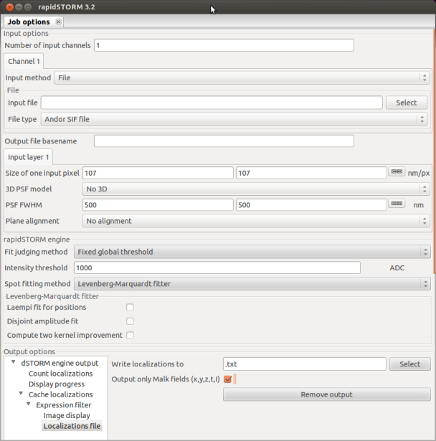

Figure 1: Enable Malk output format (tick orange box within Localizations file menu)

As a first try we will use the supplemented 2D-localization file, containing localizations of the 2D-projected 3D simulation of a microtubule (Test-Tubulin.txt).

Run the *cblpe.py* file received from the supplementary files (Fig. 2).

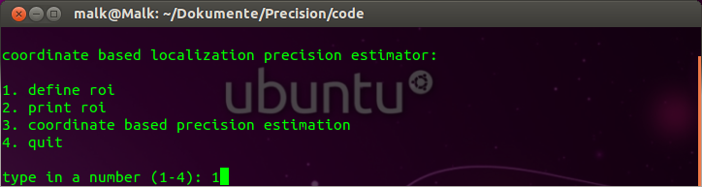

Figure 2: Main menu of cblpe.py

Choose 1 (define roi) to define a region of interest (roi) for which you would like to estimate the mean localization precision (Fig 3).

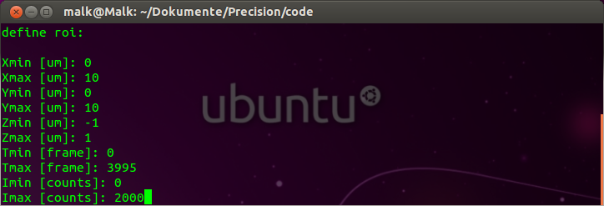

Figure 3: Define roi submenu

Define the dimensions (x, y, (z)) of the desired roi and the camera frames of interest. Also, specify the range of localization intensities in camera counts you want to use in your evaluation. Afterwards you will return to the main menu (Fig 2). If you would like to see your roi settings choose submenu 2 (print roi, Fig 4). Note that the input for the roi settings needs to be given in µm, but it will be stored in nm.

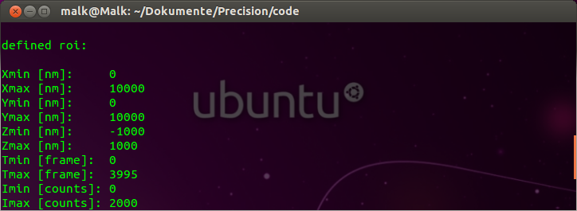

Figure 4: Show the current roi settings

To estimate the localization precision of a localization list, choose menu 3 (coordinate based precision estimation) and load the localization list (Test-Tubulin.txt, Fig 5).

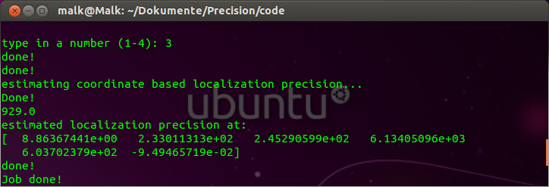

Figure 5: Results of a successful estimated localization precision

If the program is not able to find accurate fitting parameters you will have to redefine your roi settings. The simplest way would be to skip the first or last 5 frames.

**Malk Format**

The Malk format for localization files is defined in the following way. The first line is the header line, indicated by a (#). Depending on your data the first two or three columns usually contain the information about the x, y coordinates for 2D files, and the x, y, z coordinates for 3D files in nm. The last two columns should contain the information about the detection time (frame number) and the integrated intensity (AD counts, Fig 6). For more information see the [rapidSTORM](http://www.super-resolution.biozentrum.uni-wuerzburg.de/research_topics/rapidstorm/) manual.

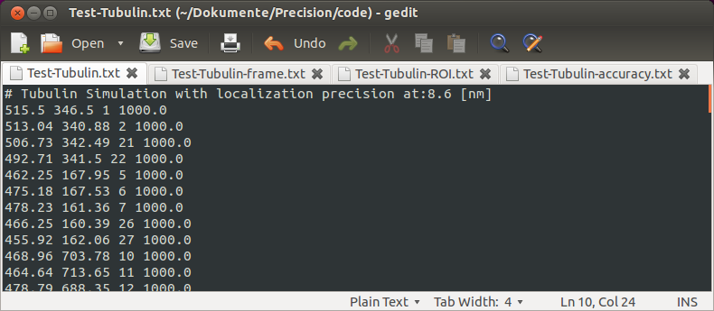

Figure 6: Input localization file, Malk format

**Result Files**

A successful estimation of localization precision will yield three different result files:

A file containing the settings of your defined roi (-frame.txt).

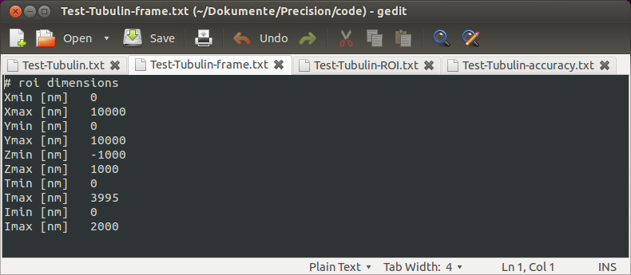

Figure 7: Definition of roi

A file containing all localizations within your defined roi (-ROI.txt).

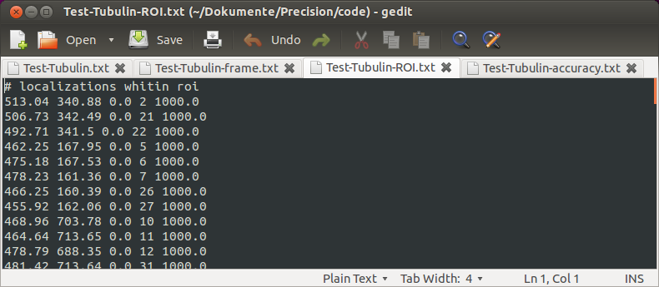

Figure 8: Localization file, containing all localizations within roi

A file containing the NNadfr distribution and the corresponding fit function of your data (-precision.txt)

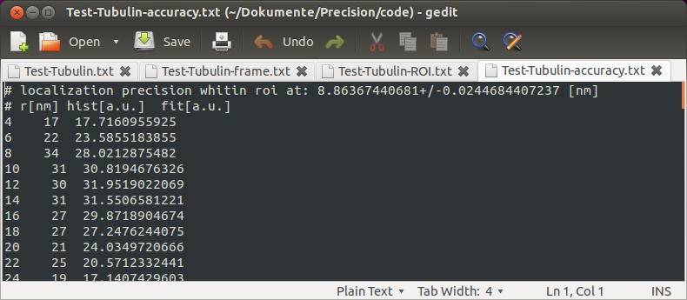

Figure 9: Localization Precision Estimation file

Here the first column represents the distance bin r[nm], the second column gives the number of NNadfr found in the bin range, and the third column gives NNadfr distribution fit values. This file can later be visualized using plotting software like [Gnuplot](http://www.gnuplot.info/).

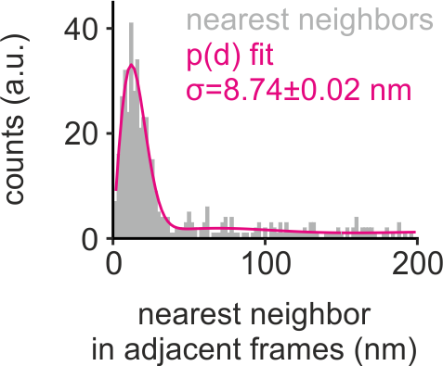

Figure 10: Visualization of localization precision estimation results

**Support**

We are grateful for any comments and bug reports on the Coordinate Based Localization Precision Estimator software and strive for active development of the software. Please report your bugs and comments. We are also interested in developing and testing new algorithms for localization-based super-resolution light microscopy. Please contact us if you are interested in such collaboration.